
GILLINGHAM SCHOOL
Hardings Lane, Gillingham, Dorset SP8 4QP

Employer: Dorset County Council

Application Form
Position applied for:
Please tell us where you saw the vacancy advertised?
Personal Details

National Insurance number:
Preferred title: |  |  |  |  |  | Mr |  |  | Mrs |  | Miss |  |  | Ms
Other: |  | Dr |  |  |  | Prof |  |  | Rev |  | Lady |  |  | Lord
Forenames (given name):
Surname (family name):
Known as:
Email
Email address:
Telephone
Home:
Work:
Mobile:
Preferred contact telephone number: |  |  | Home |  |  |  |  | Work |  |  |  | Mobile
Address
Address 1:
Address 2:
Town/City:
County:
Postcode:
Country:

Letter of Application

Please accompany this form (on a separate sheet) with a letter of application to explain how your skills, experience and knowledge would make you a suitable candidate for the post. This could include voluntary work, leisure interests and other activities, which you consider to be relevant to the position. In completing this section it is important that you refer to the requirements in the job description/person specification and provide evidence of how you meet the essential and desirable criteria.

Please see the accompanying letter for details of any post-specific aspects to be addressed within your letter.

Letters should be no more than 2 sides of A4 with font size no less than 11.

Employment History
Please give details of your employment history, starting with your current or most recent job.
Employers (from most recent) | Position and Salary | Start / Finish Dates | Reasons for Leaving

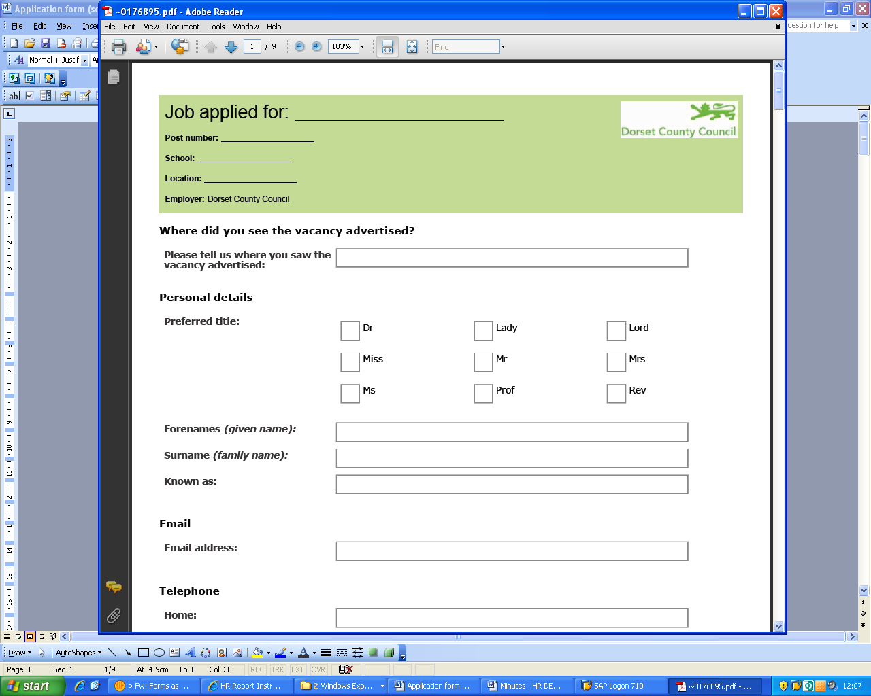
Education, qualifications and training

Shortlisted candidates will be expected to provide evidence of the qualifications listed on this application.

Qualifications including grades | Awarding body | Date
Other relevant qualifications and training
Any other relevant qualifications and training, taken or to be taken, including short courses, with dates

Membership of professional/technical bodies

Miscellaneous
Do you possess a current driving licence? |  |  | Yes | No
Do you have the use of a vehicle or other appropriate means of transport? |  |  | Yes | No
Are you currently an employee of Dorset County Council? |  |  | Yes | No
If yes, please detail your SAP Personnel number (found on your payslip):
Are you related to an employee of the council, an elected councillor, or a governor of the school? |  |  | Yes | No
If yes please give details below:
References

Please provide contact details for two people who have agreed to give an employment reference on your behalf. These references must be from your two most recent places of work or education. The council/school also reserves the right to approach any previous employer to confirm factual information about your previous employment record.

Note: References may be taken up prior to interview if you are shortlisted.

If you are not currently working with children, please ensure you provide details of one referee for the employer for whom you have most recently worked with children.

First Reference: |  |  | Second Reference:
Name of referee: |  |  | Name of referee:
Employers name: |  |  | Employers name:
Address 1: |  |  | Address 1:
Address 2: |  |  | Address 2:
Town/City: |  |  | Town/City:
County: |  |  | County:
Postcode |  |  | Postcode
Country: |  |  | Country:
Telephone number: |  |  | Telephone number:
Email address: |  |  | Email address:
Relationship to you (e.g. headteacher): |  |  | Relationship to you (e.g. headteacher):
If you wish to be contacted before references are taken up please give details below:

